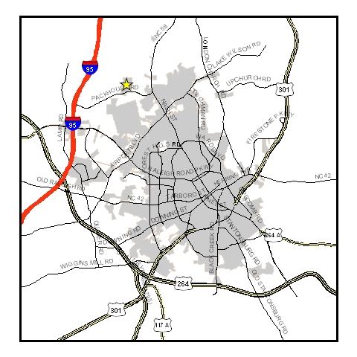

PROJECT: 20-142
AGENDA ITEM # 2
PIN # 3721-34-9130.000
DATE:July 21, 2020

DESCRIPTION: A request by Hang Lae Cho for a Special Use Permit to operate a Sweepstakes Facility/ Adult Arcade at 6601 Ward Blvd. in a HI (Heavy Industrial) zone.

.

STAFF ANALYSIS:
In its review of the request, the City Planning Staff made the following “findings of fact” and suggests that the Board, likewise, include these among any specific “findings of fact” that they make regarding this case. Any such “findings of fact” should be made by separate motion(s) and vote(s) prior to any motion and vote to grant or deny the permit.

Photos of Property

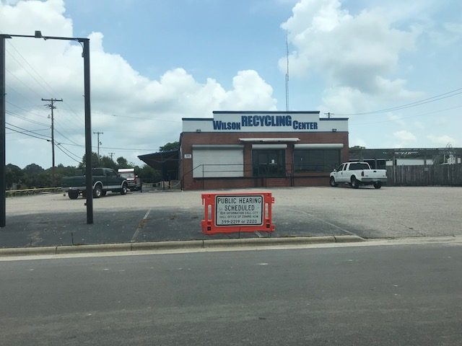

FACT 1: The property in question is located at 6601 Ward Blvd in Wilson County, North Carolina.

FACT 2: The property is also known as 3721-34-9130.000 (PIN).

FACT 3: The property is zoned HI (heavy industrial).
The surrounding properties are zoned:

North: LI (Light Industrial – across Ward Blvd.)
East: HI (Heavy Industrial)
South: HI (Heavy Industrial)
West: HI (Heavy Industrial)

FACT 4: Section 2.7.3 of the City of Wilson Unified Development Ordinance (UDO) includes a “Use Table”. That table lists a “Sweepstakes Facility/Adult Arcade”, subject to a special use permit, and subject to the requirements of Section 3.5.5 as a use permitted in the HI zone.

FACT 5: Section 17.3 of the City of Wilson UDO is entitled “Definitions, Use Types.” It includes the following definition for “Sweepstakes Facility and Adult Arcade:”

SWEEPSTAKES FACILITIES Any business enterprise, whether as a principal or accessory use, where persons utilize computers, gaming terminals, or other electronic machines to conduct games of chance, including sweepstakes, and where cash, merchandise or other items of value are earned, redeemed or otherwise distributed, whether or not the value of such distribution is determined by electronic games played or by predetermined odds. This does not include any lottery approved by the State of North Carolina. For purposes of this definition, a game of chance is one in which the element of chance is the dominating element that determines the result of the game. See also ADULT ARCADES.

ADULT ARCADES Any business enterprise, whether as a principal or accessory use, where persons utilize computers, gaming terminals, or other electronic machines to conduct games of skill, and where cash, merchandise or other items of value are redeemed or otherwise distributed, whether or not the value of such distribution is determined by electronic games played or by predetermined odds, and where the maximum value earned by any play of the game may exceed the cost for that play of the game. This does not include any lottery approved by the State of North Carolina or traditional claw-type games. For purposes of this definition, a game of skill is one in which the element of skill is the dominating element that determines the result of the game. For purposes of this ordinance, ADULT ARCADES shall be regulated similarly to SWEEPSTAKES FACILITIES.

FACT 6: Sweepstake Facilities/ Adult Arcades are also subject to the requirements of Section 3.5.5 of the UDO which states:

3.5.5 SWEEPSTAKES FACILITY/ADULT ARCADE

- General Standards
1. Selling and/or consuming alcoholic beverages are prohibited in sweepstakes facilities and/or adult arcades.

This condition applies to this request. Selling/consumption of alcohol on the premises is not permitted.

2. Persons under the age of 16 are prohibited from entering the premises during regular school hours as defined by the Wilson County Board of Education.

This condition applies to this request.

B. Separation Requirement: All sweepstakes facilities/ adult arcades shall be located at least 250 feet from any school, religious institution, or residential use.

This condition applies to this request. According to the city’s records, this facility is at least 250 feet from any school, religious institution, or residential use.

- Hours of Operation: In issuing a Special Use Permit for this use, the Board shall consider the surroundings and restrict the hours of operation of the business if they deem it warranted.

This condition applies to this request. The Board may impose hours of operation if deemed warranted by the Board. No hours of operation have been imposed on existing sweepstakes facilities/adult arcades due to the isolation of the use in only the HI zones.

D. Amortization of Existing Uses: All uses meeting the definition of Sweepstakes Facilities/ Adult Arcades as defined in Chapter 17 of this ordinance that were legitimately established prior to December 11, 2009 shall cease operations and close or be brought into compliance with the provisions of this ordinance by midnight, December 31, 2012.

This condition does not apply to this request.

FACT 7: The Neighborhood Improvement Enforcement Coordinator has indicated that there are no outstanding nuisances at this site.

FACT 8: Construction Standards and Fire may require architectural plans for any interior renovations to the structure.

FACT 9: A site plan was approved for the property on October 26, 2018 by the Technical Review Committee. The initial Special Use Permit for a Sweepstakes Facility was approved on August 21, 2018. Also the property has a Special Use Permit for a Recycling Facility approved on August 21, 2012 that continues to operate.

FACT 10: Section 9.4.1 of the UDO lists the parking requirements for Sweepstakes Facilities/ Adult Arcades. One parking space per simultaneous player is required.

A site plan showing parking delineation must be submitted and approved by the Technical Review Committee prior to operation.

FACT 11: Construction Standards and Fire have indicated that the proposed use will be a change of use of the structure. Architectural plans will be required. This property shall be in compliance with MUTCD and ADA requirements.

FACT 12: Section 15.10.2.E of the UDO, pertaining to the issuance of special use permits, reads as follows:

- That the proposed special use conforms to the character of the neighborhood, considering the location, type and height of buildings or structures and the type and extent of landscaping on the site;

- That adequate measures will be taken to provide ingress and egress so designed as to minimize traffic hazards and to minimize traffic congestion on the public roads;

- That adequate utilities (water, sewer, drainage, electric, etc.) are available for the proposed use;

- That the proposed use will not be noxious or offensive by reason of vibration, noise, odor, dust, smoke or gas;

- That the establishment of the proposed use will not impede the orderly development and improvement of surrounding property for uses permitted within the land development district;

- That the establishment, maintenance and/or operation of the proposed use will not be detrimental to or endanger the public health, safety or general welfare; and

- That the establishment will be operated in compliance with all local, state and federal laws and will not become a nuisance by creating criminal activity or public disturbance.

PROCEDURE: The Board must proceed in accordance with Section 15.10.2.E as quoted in Fact 12.

RECOMMENDATION: Staff recommends the Board proceed as follows:

- Move that Facts 1-12 in the staff findings be adopted as “findings of fact” of the Board (motion-second-and vote).

- Move to Conclude:

- that the requested permit is within the jurisdiction of the Board to issue;

- that the application is complete; and

- that, if completed as proposed in the application and in compliance with the recommended conditions, the development will comply with the requirements of the Unified Development Ordinance.

- Move to grant the Special Use Permit subject to the following conditions:

- The applicant and operator of the establishment shall fully comply with all of the requirements of the order, including, but not limited to, any other applicable state or local rules, ordinances, laws and regulations of whatever nature.

- If any of the conditions affixed to the permit or any part thereof shall be held invalid or void, then the permit shall become void and of no effect.

- The applicant shall comply with all applicable requirements of Section 3.5.5 (see Fact 6) of the Unified Development Ordinance.

- All signs shall comply with Section 11 of the Unified Development Ordinance and acquire a sign permit. Please contact the Permit Desk for additional information at 252.399.2220.

- The Special Use Permit is granted for a Sweepstakes Facility/Adult Arcade with an equal ratio of parking spaces to maximum simultaneous players on premise as shown on the Technical Review Committee (TRC) approved site plan, ONLY. Any deviation in the site plan shall require a revised plan to be submitted for approval by the TRC.

- Any gaming units not in use cannot be stored on site except, with prior notification to Land Development in cases where existing machines are switched out and replaced.

- If renovations are proposed for the building, architectural plans shall be submitted to Construction Standards and Fire for review. The Fire Marshall and Construction Standards staff must conduct inspections of the premises prior to the opening of business. Please contact the Permit Desk for additional information at 252.399.2220.

- The applicant does agree that he/she has read and understood the above-listed information, and does hereby expressly reaffirm, consent to, agree to abide by, and remain in compliance with the plan(s), requirements and/or conditions listed therein and that he/she shall conduct such business in full compliance with all local, state, and federal laws and regulations applicable thereto. The applicant further acknowledges and agrees that the City of Wilson makes no representation or acknowledgement that the business is in compliance with said laws and regulations.

- The Special Use Permit will expire on third Tuesday of August 2022. The applicant must submit an application for renewal to the Development Services Department by the third Tuesday in July 2022.

