# Safe Surrender

The Safely Surrendered Baby Law, signed permanently into state law in 2001, allows parents or other persons, with lawful custody, which means anyone to whom the parent has given permission, to confidentially surrender a baby. As long as the baby is three days (72 hours) of age or younger and has not been abused or neglected, the baby may be surrendered without fear of arrest or prosecution.

The law requires the baby be taken to a public or private hospital, designated [fire station](https://www.wilsonnc.org/residents/city-services/all-departments/wilson-fire-rescue-services/fire-stations-and-apparatus) or other safe surrender site. No questions will be asked. Members of the Fire Department assume responsibility for the safety and medical treatment of infants surrendered to them and placed in their care.

A medical questionnaire will be offered for the sole purpose of collecting medical information critical to the health and survival of the infant. All identifying information that pertains to a parent or individual who surrenders a child is strictly confidential. The medical questionnaire is a voluntary document and can be declined. If you have any additional questions regarding the Safe Surrender for Newborns Program or would like more information, please contact the resources listed below.

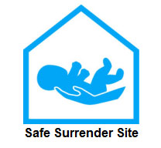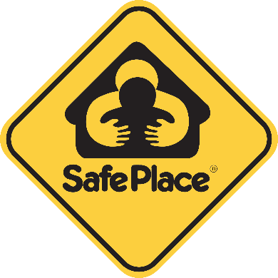

Additional Resources:

[Information for Women in Crisis](https://files.nc.gov/ncdhhs/safesurrenderfactsforcrisis.pdf)

<https://www.ncdhhs.gov/divisions/social-services/wilson-county-department-social-services>

<https://www.ncleg.net/EnactedLegislation/SessionLaws/HTML/2001-2002/SL2001-291.html>

<https://www.ncdhhs.gov/assistance/pregnancy-services/safe-surrender#:~:text=North%20Carolina%E2%80%99s%20Safe%20Surrender%20Law%20allows%20a%20parent,to%20prevent%20newborns%20from%20being%20hurt%20or%20abandoned>.