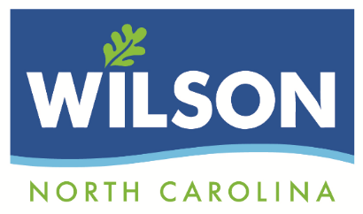

|  |
| --- |
| **BOARD OF ADJUSTMENT**  **AGENDA**  **March 15, 2022**  **5:30 P.M.** |
| **RULES FOR PERSONS ADDRESSING THE BOARD OF ADJUSTMENT**  **1. Each speaker will identify him/herself by giving his or her name and place of residence.**  **2. Each speaker will be limited to speaking one time on any topic. When you are finished speaking, please step away from the podium and be seated.**  **3. Each speaker will be limited to five (5) minutes and each group’s representative will be limited to a maximum of ten (10) total minutes. Each group is encouraged to designate a single spokesperson for their group.**  **4. Each speaker will confine him/herself to the general question before the Board and avoid irrelevant comments.** |

**Call meeting to Order**

**Organizational Meeting:** Election of Officers (Chairman, Vice-Chairman)

Rules of Procedure

**Approval of Minutes:** January 18, 2022

**Swear-in and Affirmations**

**New Business**

1. A request by Crown Castle for a Special Use Permit renewal to allow the applicant to continue to operate a Wireless Communication Facility at 445 Ward Blvd. (Project # 22-59)
2. A request by Crown Castle for a Special Use Permit renewal to allow the applicant to continue to operate a Wireless Communication Facility at 4222 Ward Blvd. (Project # 22-60)

**Adjournment**

Next Scheduled Meeting: April 19, 2022