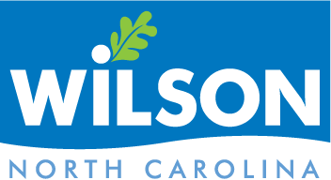

City of Wilson

Historic Preservation Commission

AGENDA

February 1, 2023 5:30pm

Council Chambers : 3rd Floor, City Hall : 112 Goldsboro Street E.

1. Call to Order
2. Attendance

Determination of Quorum

1. Approval of Minutes

January 4, 2023

1. Action Items

New: 2023-02-01 305 Tarboro Street NE

1. New Business
2. Old Business
3. Adjournment
4. Executive Session

Standards Draft Review

Next Meeting: March 1, 2023