**PROJECT: 24-162**

**AGENDA ITEM # 1**

**PIN # 3722-20-7029.000**

**DATE: May 21, 2024**

**DESCRIPTION:** A request by Kiersten Chesson on behalf of The Porch at Iconostar for a Special Use Permit to operate a Bar/Tavern/Art Gallery at 224 Goldsboro St, SW in a CCMX zone.

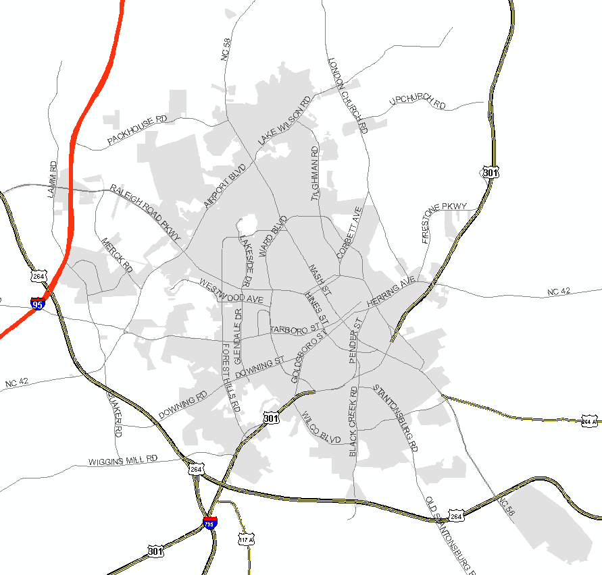

**STAFF ANALYSIS:**

In its review of the request, the City Land Development Staff made the following “findings of fact” and suggests that the Board, likewise, include these among any specific “findings of fact” that they make regarding this case. Any such “findings of fact” should be made by separate motion(s) and vote(s) prior to any motion and vote to grant or deny the permit.

**Photos of Property**

Aerial View:

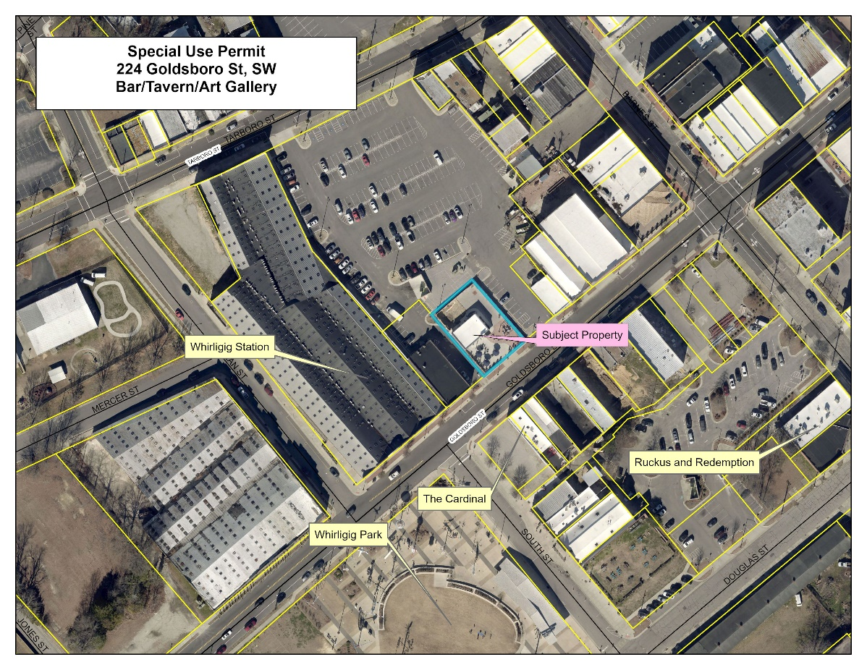

Street Views:

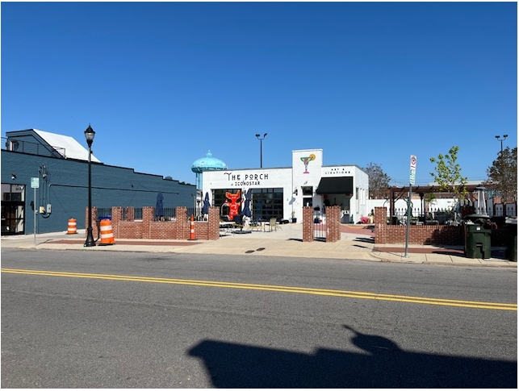

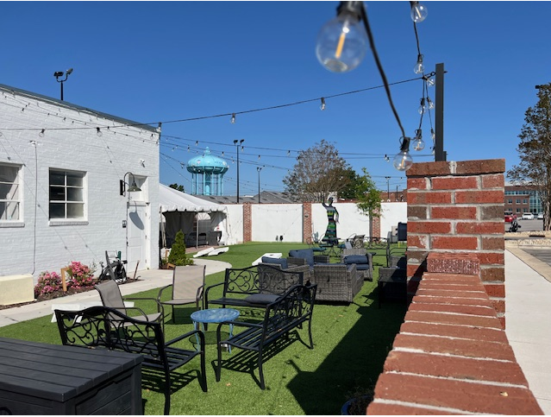

FACT 1: The property in question is located at 224 Goldsboro St, SW, Wilson County, North Carolina.

FACT 2: The property is also known as 3722-20-7029.000 (PIN)

FACT 3: The property is zoned CCMX (Center City Mixed-Use).

The surrounding properties are zoned CCMX (Center City Mixed-Use).

FACT 4: The property is located within the Municipal Service District and the Downtown/Tobacco Warehouse Historic District of the City of Wilson.

FACT 5: Iconostar was originally renovated as an art studio and gallery for the owner on December 21, 2020 (Building Permit #20-92). The site was enclosed by a masonry wall that allowed for seating and art displayed throughout. On June 21, 2022 a Special Use Permit was granted for a Bar & Tavern and, thereafter, an alcohol permit was issued from the NC Alcohol Beverage Commission (ABC).

.

FACT 6: A new business owner, Kierston Chesson, submitted a Development Compliance Certificate (DCC) in October of 2023 for The Porch at Iconostar. In November of 2023, Ms. Chesson requested and received an ABC permit from the State of North Carolina. The area between the building and the masonry wall was expanded to include additional tables and chairs.

FACT 7: The new business owner for The Porch at Iconostar is petitioning to renew the special use permit to operate as a Bar & Tavern with the art gallery continuing as a subordinate use.

FACT 8: As per the Fire Marshal Office, the building occupancy is 17 and the exterior area enclosed by the masonry wall has an occupancy of 75 for a total of 92 occupants on the property.

FACT 9: Chapter 17 of the City of Wilson Unified Development Ordinance defines **Bar/Tavern** as:

“A business where alcoholic beverages are sold for on-site consumption, which are not part of a larger restaurant. Includes bars, taverns, pubs, and similar establishments where any food service is subordinate to the sale of alcoholic beverages. May also include beer brewing as part of a microbrewery and other beverage tasting facilities.”

FACT 10: Section 2.7.3 of the City of Wilson Unified Development Ordinance includes a “Use Table”. The table lists “Bar, Tavern, or Nightclub subject to a Special Use Permit and subject to the requirements of 3.5.3” as a permitted use in the CCMX district.

FACT 11: Section 3.5.3 of the City of Wilson Unified Development Ordinance is entitled “Requirements for particular uses and development types – nightclub” and lists the requirements as follows:

3.5.3 BAR, TAVERN, or NIGHTCLUB

A. Separation Requirement: All new bar, tavern, nightclubs in the GC and HC districts shall be located no closer than 500 feet to any residential district or use, church, school, park or playground, or other existing public or private club.

*This property is not in the GC or HC districts, so this requirement does not apply to this request.*

B. Minimum Net Floor Area: Bars and Taverns shall have a minimum floor area of 1,200 square feet.

*The subject property meets the requirement as follows:*

*Total net floor area of 1,075 square feet as per the Wilson County Tax Administration website. The fenced area has an approximate net area of 7,000 square feet of the 8,276 square feet.*

C. Hours of Operation: In issuing a Special Use Permit for this use, the board shall consider the surroundings and restrict the hours of operation of the business if they deem it warranted.

*The business will close no later than is allowed in accordance with NC ABC laws.*

FACT 12: Wilson Downtown Development Corporation (WDDC) reviewed this request and supports this request with Conditions 1 - 11.

FACT 13: The Fire Department recommends approval subject to the following:

The property is located within the Primary Fire District within the City and shall continue to meet the district standards, any NC Fire Prevention Code requirements and have an approved inspection in accordance with the NC Fire Code schedule.

FACT 14: Neighborhood Improvement recommends approval subject to the following:

Must continue to follow all applicable local, state, and federal laws, rules, and ordinances.

FACT 15: Construction Standards recommends approval subject to the following:

Must continue to comply with the current edition of the NC Building Code.

FACT 16: Section 15.10.2E of the Unified Development Ordinance: pertaining to the issuance of Special Use Permits, reads as follows:

1. That the proposed special use conforms to the character of the neighborhood, considering the location, type and height of buildings or structures and the type and extent of landscaping on the site;

*This request conforms to the character of the neighborhood and with the direction of the Wilson Downtown Development Corporation within the existing building.*

1. That adequate measures will be taken to provide ingress and egress so designed as to minimize traffic hazards and to minimize traffic congestion on the public roads;

*This request should not impact negatively on traffic congestion on the public roads. There is public parking on Barnes Street in front of the business, Parking Lot #16 (formerly Centre Brick Parking Lot) and a public parking lot adjacent to the rear of the property at 210 Barnes Street (Parking Lot #7).*

1. That adequate utilities (water, sewer, drainage, electric, etc.) are available for the proposed use;

*Adequate utilities are available for the proposed use.*

1. That the proposed use will not be noxious or offensive by reason of vibration, noise, odor, dust, smoke or gas;

*This request should not be noxious or offensive by reason of vibration, noise, odor, dust, smoke, or gas. Any creation of such items would require meeting state and federal standards or requirements.*

1. That the establishment of the proposed use will not impede the orderly development and improvement of surrounding property for uses permitted within the land development district; and

*This request will not impede the orderly development and improvement of surrounding property for uses permitted within the CCMX (Center City Mixed-Use) by allowing this use within Historic Downtown Wilson.*

1. That the establishment, maintenance and/or operation of the proposed use will not be detrimental to or endanger the public health, safety or general welfare.

*This request, if operated as described, should not be detrimental to or endanger the public health, safety or general welfare of the property owners, residents and visitors to the City of Wilson. Conditions in the Recommendations Section are applicable to the compliance of this requirement.*

1. That the establishment will be operated in compliance with all local, state and federal laws and will not become a nuisance by creating criminal activity or public disturbance.

*The request, if operated as described, should be compliant with all laws and not become a nuisance to the downtown area. Conditions in the Recommendations Section should assist in monitoring the operation of this proposed business.*

PROCEDURE: The Board must proceed in accordance with Section 15.10 as quoted in Fact 16 (motion-second-and vote).

RECOMMENDATION: Staff recommends the Board proceed as follows:

- **Move that Facts 1-16 in the staff findings be adopted** **as “findings of fact” of the Board** **(motion-second-and vote).**

* **Move to Conclude**: **(motion-second-and vote)**

1. that the requested permit is within the jurisdiction of the Board to issue;
2. that the application is complete; and
3. that, if completed as proposed in the application and in compliance with the recommended conditions, the development will comply with the requirements of the Unified Development Ordinance.

* **Move to grant the Special Use Permit** **subject to the following conditions: (motion-second-and vote).**

1. The applicant and operator of the establishment shall fully comply with all of the requirements of the Order together with any other applicable state or local rules, ordinances, laws and regulations of whatever nature.
2. If any of the conditions affixed to the permit or any part thereof shall be held invalid or void, then the permit shall become void and of no effect.
3. The Special Use Permit is granted for Bar & Tavern, ONLY.
4. All required building permits, inspections, and a fire inspection will be maintained throughout the duration of the business operation.
5. Must comply with the current edition of the NC Building Code and have an approved Certificate of Occupancy prior to commencing operation.
6. Any pattern of recurring incidents of violence, illegal, or nuisance activity, which results in at least two incidents over 3 days, or more than 9 events over 90 days, reported to the City of Wilson Police Department or the City of Wilson Nuisance Department, shall be grounds to schedule a hearing with the Board of Adjustment for a warning to revoke or revocation of the Special Use Permit. In addition, if there is a serious violent crime such as rape, homicide, or serious assault, shall be potential grounds to schedule a hearing with the Board of Adjustment for a warning to revoke or revocation of the Special Use Permit. The Special Use Permit hearing shall be for revocation of the Special Use Permit or placing additional amendments to the Conditions of Approval. Upon Revocation, the business shall immediately be closed.
7. After closing each night, the on-site manager shall pick-up, dispose of properly, and clean-up outside areas within 50 feet of the building. This includes the trash, refuse, or other evidence of public drunkenness.
8. A City of Wilson privilege license as related to the alcohol permits will be maintained at all times.
9. All exterior lighting shall be directed downward to prohibit fugitive light from leaving the area/building. All lighting shall be extinguished, (except for the light necessary for security lights) within 30 minutes of the close of business.
10. The Special Use Permit will expire on the third Tuesday of May 2026. The applicant should submit an application to renew the Special Use Permit by the third Tuesday of April 2026.
11. The business will close no later than is allowed in accordance with NC ABC laws.

**ATTACHMENTS:** 1) Application. 2) Adjacent Property Owners Labels.