|  |
| --- |
| ***For Internal Use Only – This registration accepted/reviewed by:*** |

2024 Membership / Registration Form www.wilsonpdpal.org

|  |  |  |  |  |
| --- | --- | --- | --- | --- |
| Participant’s Name | | | | Today’s Date |
| Street Address | | City | | Zip Code |
| **Gender** □ Male □ Female | **Ethnicity** □ Asian □ Black or African American □ Hispanic or Latino  □ Native Hawaiian or Other Pacific Islander □White | | | |
| School | Grade (as of January 1, 2024) | | Age | Date of Birth |
| Home Phone |  | | | |
| Parent’s/Guardian’s Name *(Please print.)* | E-mail address *(Please print.)* | | | |
| Parent’s/Guardian’s Work Phone | Parent’s/Guardian’s Cell Phone | | | |
| Grandparent’s Name *(Please print.)* | E-mail address *(Please print.)* | | | |
| Grandparent’s Work Phone | Grandparent’s Cell Phone | | | |
| Alternate/Back Up Emergency Contact Name (and relationship) | Alternate/Back Up Emergency Contact Phone | | | |
| **MEDICAL HISTORY** | | | | |
| Medical conditions currently under treatment | | | | |
|  | | | | |
|  | | | | |
| Pre-existing injuries under treatment | | | | |
|  | | | | |
|  | | | | |
| Fractures or other disability-type injuries | | | | |
|  | | | | |
|  | | | | |
| Allergies (drug, food, asthma, etc.) *Note: If your child has asthma, please send his/her inhaler with him/her. Please make sure it is marked with his/her name. If he/she has allergies that require him/her to carry an Epi pen, please send that marked with his/her name.* | | | | |
|  | | | | |
|  | | | | |
| Medications required or presently taking | | | | |
|  | | | | |

|  |  |  |  |
| --- | --- | --- | --- |
| **Waiver and Consent for Medical Treatment** | | | |
| Name of Child | | | |
| In consideration of its allowance of my child to participate in its program, I hereby release and waive the Wilson Police Athletic League, and its employees, agents, representatives, officers, directors, sponsors, and other organizations assisting PAL from any and all liability for any loss or injury sustained or incurred (including any loss or injury resulting from the representatives, officers, and directors) while my child participates in PAL’s program, or while traveling to or from PAL’s program. If I cannot be reached in the event of an emergency, I authorize any physician treating my child to perform any and all medical procedures which the physician determines to be medically appropriate under the circumstances. | | | |
|  | **Parent/Guardian’s Name *(Please print.)*** | |  |
|  | |
|  | **Parent/Guardian’s Signature** |  | |
|  |
| **Date** | | | |
| **Talent Release Agreement** | | | |
| I hereby assign and grant to the City of Wilson and the Wilson Police Department the right and permission to use and publish the photographs/film/videotapes/electronic representations and/or sound recordings made of me or my child by the City of Wilson and the Wilson Police Department, and I hereby release the City of Wilson and the Wilson Police Department from any and all liability from such use and publication. I hereby authorize the reproduction, sale, copyright, exhibit, broadcast, electronic storage, and/or distribution of said photographs/film/ videotapes/electronic representations and/or sound recordings without limitation at the discretion of the City of Wilson and the Wilson Police Department, and I specifically waive any right to any compensation I may have for any of the foregoing. | | | |
|  | **Parent/Guardian’s Signature** |  | |
|  |
| **Date** | | | |
| **Student-Athlete & Parent/Legal Custodian Concussion Statement\*** | | | |
| We were given a copy of the *Student-Athlete & Parent/Legal Custodian Concussion Information Sheet*, and we have read and understand the information provided*.*  ***Parent/Guardian’s Signature***  *__________________________________________________________________________________*  *If there is anything on this sheet that you do not understand, please ask an adult to explain or read it to you**.** | | | |

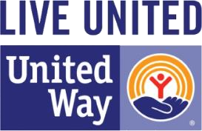*Wilson Police Athletic League is a United Way designation-only*

[*o*](http://www.wilsonpdpal.org/)

*r*

*mmincey@wilsonnc.org*

*or (252)399*

*-*

*2316*

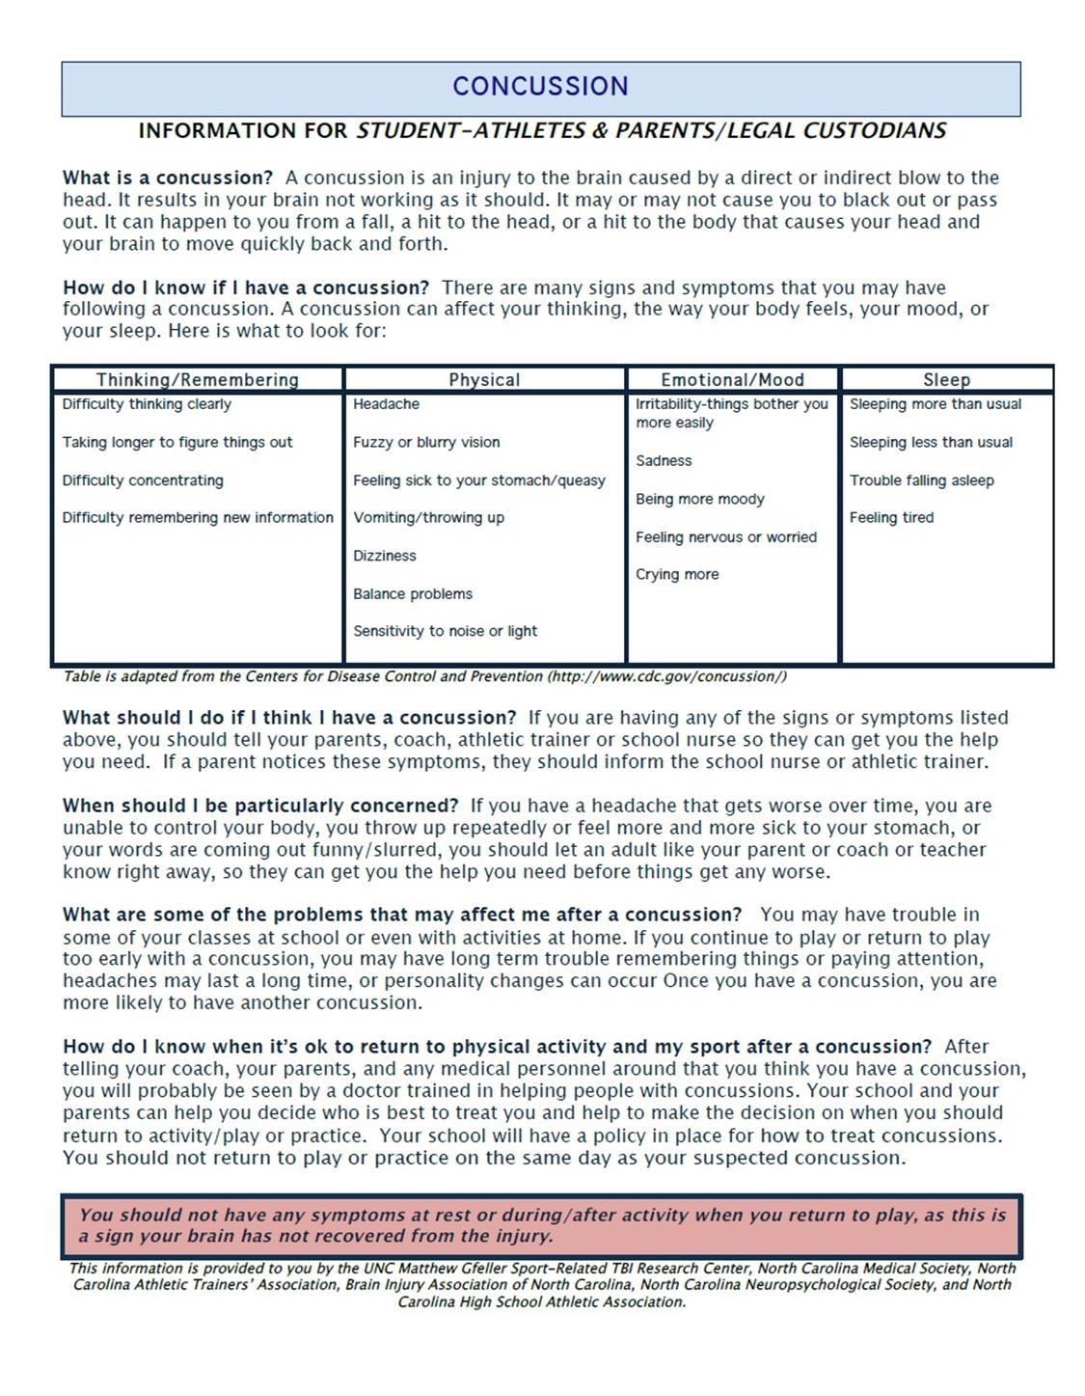

[*o*](http://www.wilsonpdpal.org/)

*r*

*mmincey@wilsonnc.org*

*or (252)399*

*-*

*2316*

