**PROJECT: 24-244**

**AGENDA ITEM # 1**

**PIN # 3722-25-1347.000**

**DATE: July 16, 2024**

**DESCRIPTION:** A request by Herring-Sutton on behalf of Alpha Sigma Phi Fraternity for a Special Use Permit to operate a Fraternity/Sorority House at 902 Gold Street, N in a GR6 zone.

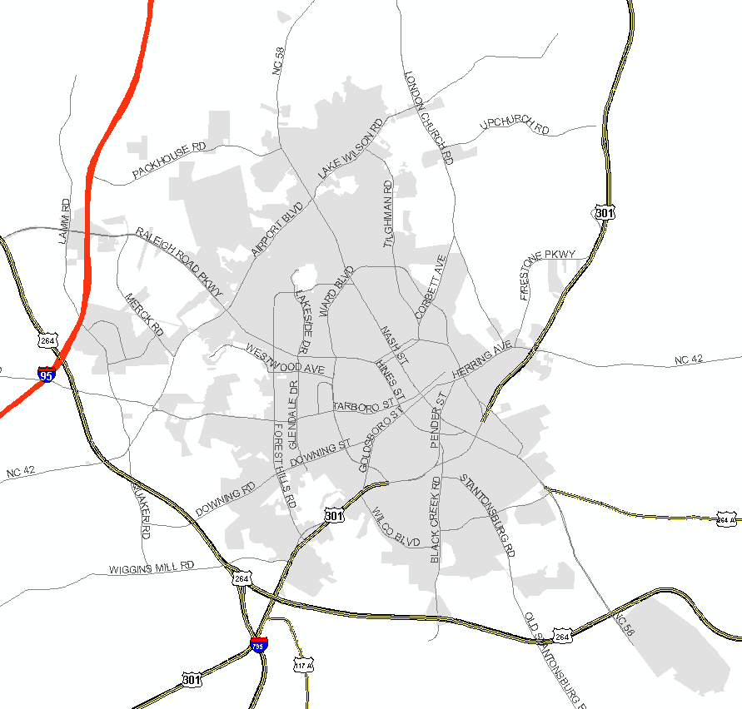

**STAFF ANALYSIS:**

In its review of the request, the City Land Development Staff made the following “findings of fact” and suggests that the Board, likewise, include these among any specific “findings of fact” that they make regarding this case. Any such “findings of fact” should be made by separate motion(s) and vote(s) prior to any motion and vote to grant or deny the permit.

**Photos of Property**

Aerial View:

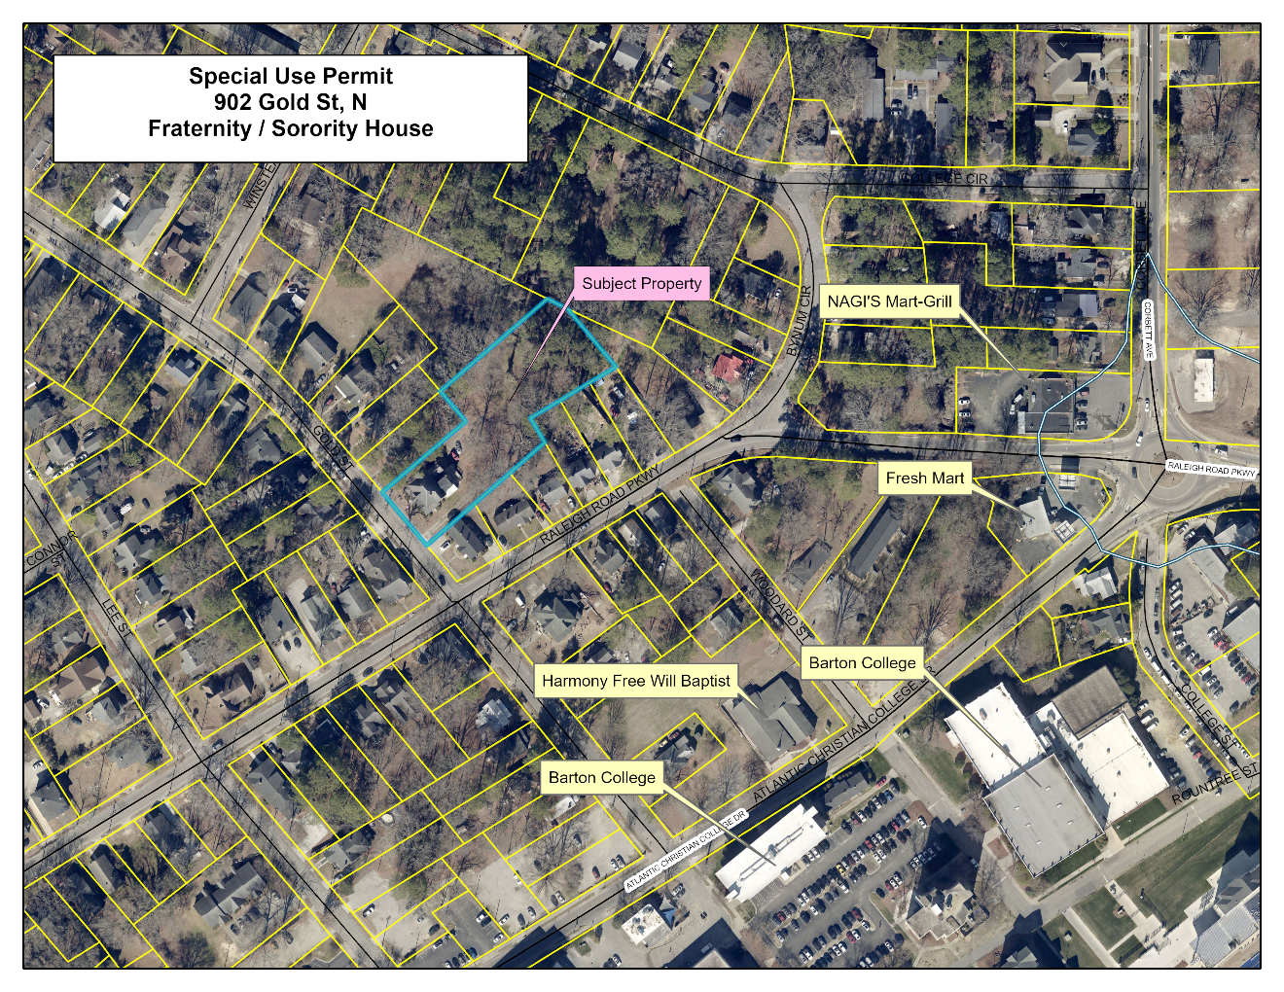

Street View:

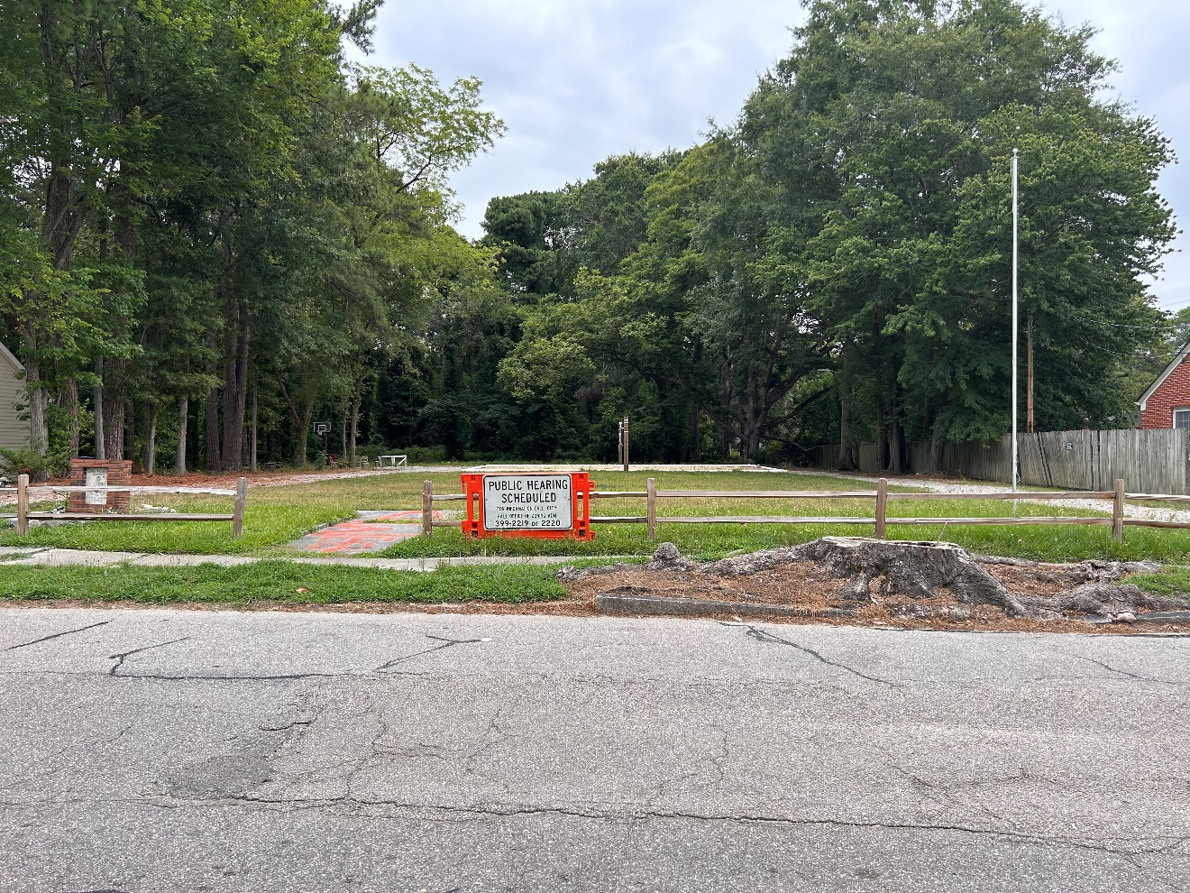

FACT 1: The property in question is located at 902 Gold St, N Wilson County, North Carolina.

FACT 2: The property is also known as 3722-25-1347.000 (PIN)

FACT 3: The property is zoned GR6 (General Residential Medium Density).

The surrounding properties are zoned GR6 (General Residential Medium Density).

FACT 4: The most recent use of the property was a 3,101 square foot dwelling that once housed the Alpha Sigma Phi Fraternity House. Barton College (formerly Atlantic Christian College) website indicates the fraternity was organized in 1958. This property was purchased by Alpha Sigma Phi in 1968 and the residence constructed.

FACT 5: The most recent special use permit renewal was issued on June 16, 2009 for the fraternity/sorority house. This special use permit expired April 20, 2010 with no record of renewal.

FACT 6: In 2023, a demolition permit was submitted to the City of Wilson. The demolition permit was approved on August 21, 2023. The existing dwelling has been demolished. The final inspection has not been requested by the contractor. The permit will expire on August 21, 2024.

FACT 7: The application and floor plan indicate a proposed 2-story, 3 bedroom, 2,792 square foot fraternity house. The site plan includes 9 proposed parking spaces including 1 handicap space.

FACT 8: This property is not located within the FEMA designated floodway or a 100-year floodplain, nor in the Special Flood Hazard Conservation Area (SFHCA).

FACT 9: Chapter 17 of the City of Wilson Unified Development Ordinance defines **FRATERNITY/SORORITY HOUSE** as:

“A structure used to provide housing for fraternal or sisterhood organization members while such persons are attending college.”

FACT 10: Section 2.7.3 of the City of Wilson Unified Development Ordinance includes a “Use Table”. The table lists “FRATERNITY/SORORITY HOUSE subject to a Special Use Permit and subject to the requirements of 3.3.3” as a permitted use with conditions in the GR6 zone.

FACT 11: Section 3.3.3 of the City of Wilson Unified Development Ordinance is entitled “Requirements for particular uses and development types” and lists the requirements as follows:

3.3.3 FRATERNITY/SORORITY HOUSE

A. UR and RMX Districts: The minimum lot size in UR and RMX Districts shall be 10,000 square feet.

*This condition does not apply to this request. This property is not located in the UR or RMX districts.*

B. Space per Resident: There shall be a minimum of 250 square feet of usable building space per resident.

*This condition applies to this request. According to the preliminary floor plan the proposed building area is 2,792 square feet. This would allow 11 persons in the residence. Plans must be submitted to Development Services for review and approved prior to the issuance of any permits.*

C. Buffering: Where a fraternity/sorority house adjoins a Single Family or Two Family dwelling, a Type A Buffer is required along all shared property lines.

*This condition applies to this request. A site plan must be submitted to the Technical Review Committee for review and approval prior to issuance of any development permits*

D. Parking: For the purposes of the Chapter 9 parking regulations, fraternity/sorority houses shall be considered apartments.

*This condition applies to this request. The floor plans indicate 3 bedrooms and Chapter 9 indicates a requirement of 1.5 parking spaces per unit. Staff is interpreting each bedroom as a unit and a minimum of 5 parking spaces shall be required. The application indicates 9 proposed parking spaces. A site plan must be submitted to the Technical Review Committee for review and approval prior to issuance of any development permits.*

FACT 12: Construction Standards recommends approval subject to the following:

Must comply with the current edition of the NC Building Code. Construction Standards has indicated that the proposed use will require plans prior to the issuance of any construction permits.

FACT 13: The Fire Department recommends approval subject to the following:

The property must comply with any NC Fire Prevention Code requirements and have an approved inspection in accordance with the NC Fire Code schedule. The sprinkler system shall be inspected by a third party and the annual inspection report included with the routine fire inspection.

FACT 14: Neighborhood Improvement recommends approval subject to the following:

Must follow all applicable local, state, and federal laws, rules, and ordinances.

FACT 15: Section 15.10.2E of the Unified Development Ordinance: pertaining to the issuance of Special Use Permits, reads as follows:

1. That the proposed special use conforms to the character of the neighborhood, considering the location, type and height of buildings or structures and the type and extent of landscaping on the site;

*This request conforms to the character of the neighborhood.*

1. That adequate measures will be taken to provide ingress and egress so designed as to minimize traffic hazards and to minimize traffic congestion on the public roads;

*This request should not impact negatively on traffic congestion on the public roads.*

1. That adequate utilities (water, sewer, drainage, electric, etc.) are available for the proposed use;

*Adequate utilities are available for the proposed use.*

1. That the proposed use will not be noxious or offensive by reason of vibration, noise, odor, dust, smoke or gas;

*This request should not be noxious or offensive by reason of vibration, noise, odor, dust, smoke, or gas. Any creation of such items would require meeting state and federal standards or requirements.*

1. That the establishment of the proposed use will not impede the orderly development and improvement of surrounding property for uses permitted within the land development district; and

*This request will not impede the orderly development and improvement of surrounding property for uses permitted within the GR6 zone.*

1. That the establishment, maintenance and/or operation of the proposed use will not be detrimental to or endanger the public health, safety or general welfare.

*This request, if operated as described, should not be detrimental to or endanger the public health, safety or general welfare of the property owners, residents and visitors to the City of Wilson. Conditions in the Recommendations Section are applicable to the compliance of this requirement.*

1. That the establishment will be operated in compliance with all local, state and federal laws and will not become a nuisance by creating criminal activity or public disturbance.

*The request, if operated as described, should be compliant with all laws and not become a nuisance. Conditions in the Recommendations Section should assist in monitoring the operation of this proposed business.*

PROCEDURE: The Board must proceed in accordance with Section 15.10 as quoted in Fact 15 (motion-second-and vote).

RECOMMENDATION: Staff recommends the Board proceed as follows:

- **Move that Facts 1-15 in the staff findings be adopted** **as “findings of fact” of the Board** **(motion-second-and vote).**

* **Move to Conclude**: **(motion-second-and vote)**

1. that the requested permit is within the jurisdiction of the Board to issue;
2. that the application is complete; and
3. that, if completed as proposed in the application and in compliance with the recommended conditions, the development will comply with the requirements of the Unified Development Ordinance.

* **Move to grant the Special Use Permit** **subject to the following conditions: (motion-second-and vote).**

1. The applicant and operator of the establishment shall fully comply with all of the requirements of the Order together with any other applicable state or local rules, ordinances, laws and regulations of whatever nature.
2. If any of the conditions affixed to the permit or any part thereof shall be held invalid or void, then the permit shall become void and of no effect.
3. The Special Use Permit is granted for a Fraternity/Sorority House ONLY.
4. The applicant shall comply with all applicable requirements of Section 3.3.3 of the Unified Development Ordinance.
5. The open demolition permit needs to be resolved prior to issuance of any permits to the new construction.
6. All construction must comply with the current edition of the North Carolina State Building Codes.  Permits will be issued with approval of construction plans.
7. A copy of the sprinkler system annual inspection report shall be required at the periodic fire inspections for the fraternity house.
8. Any current or future accessory buildings on the property shall be utilized solely for storage or auxiliary work space or removed entirely. In no event shall the accessory building be utilized for dwelling or sleeping purposes.
9. Any pattern of recurring incidents of violence, illegal, or nuisance activity, which results in at least two incidents over 3 days, or more than 9 events over 90 days, reported to the City of Wilson Police Department or the City of Wilson Nuisance Department, shall be grounds to schedule a hearing with the Board of Adjustment for a warning to revoke or revocation of the Special Use Permit. In addition, if there is a serious violent crime such as rape, homicide, or serious assault, shall be potential grounds to schedule a hearing with the Board of Adjustment for a warning to revoke or revocation of the Special Use Permit. The Special Use Permit hearing shall be for revocation of the Special Use Permit or placing additional amendments to the Conditions of Approval. Upon Revocation, the business shall immediately be closed.
10. Where neighborhood complaints are such that appeals are made to the Board of Adjustment, the Board shall hear such complaints and make necessary findings as to whether or not to revoke the Special Use Permit and/or set forth additional conditions of operation to further ensure or encourage compatibility and non-detrimental impact of the use within the neighborhood.
11. There must be one police officer for every 50 guests, or fraction thereof, at all events held at the fraternity house.
12. All exterior lighting shall be directed downward to prohibit fugitive light from leaving the area/building. All lighting shall be extinguished, (except for the light necessary for security lights) within 30 minutes of the close of business.

**ATTACHMENTS:** 1) Application. 2) Site Plan Sketch. 3) Floor Plans.